Healthcare Analytics Dashboard Using Power BI

Dataset Names:

Patient Medical Records Dataset

Hospital Treatment Details Dataset

Prepared By:

Name: Upendra Pippal

Patients medical dataset- Dataset 1

Hospitals Treatment Dataset- Dataset 2

Tool Used: Microsoft Power BI Desktop

PowerBI file: Healthcare.pbix

PowerBI Dashboard: Healthcare_dashboard

Project Overview

Introduction

This project focuses on analyzing healthcare data using Microsoft Power BI to gain meaningful insights into patient information, treatments, hospital performance, and medical outcomes.
The analysis is based on two related datasets:
- Patient Medical Records Dataset, which contains demographic and medical details of patients such as age, gender, diagnosis, admission and discharge dates, and medical history.
- Hospital Treatment Details Dataset, which includes information related to treatments, procedures, costs, departments, and hospital services provided to patients.
These datasets are combined and analyzed to create an interactive healthcare analytics dashboard that helps understand trends, patterns, and operational performance within a healthcare system.

Business Objective
The main objectives of this project are:
- To analyze patient demographics and medical conditions
- To evaluate treatment patterns and hospital service utilization
- To identify trends related to admissions, discharges, and treatment costs
- To answer healthcare-related business questions using Power BI visualizations
- To support data-driven decision-making for hospital management and healthcare planning
By transforming raw healthcare data into interactive dashboards, this project demonstrates how analytics can improve operational efficiency, patient care insights, and strategic planning.

Part 1: Data Cleaning, Modeling, and DAX in Power BI

1. Data Importing and Initial Examination:
Import both datasets into Power BI. Perform a preliminary examination of the data. Identify any data quality issues or inconsistencies.

Both datasets were imported into Power BI using the Get Data option. After importing, the data was opened in Power Query Editor to understand the structure of the datasets.
In the initial examination, the following checks were performed:
- Number of rows and columns in each dataset
- Column names and their meaning
- Data types such as text, numbers, and dates
- Missing or blank values in the data
Issues Found in the Data
- Some columns contained missing or empty values
- A few columns had wrong data types (for example, dates stored as text)
- Some categorical values were written in different formats or spellings
- A small number of duplicate records were found
This step helped to understand the data better and identify the problems that needed to be fixed before starting the analysis.

2. Merging and Relating Datasets
Merge the datasets using a suitable column as a key. Ensure that the merge is accurate and retains all necessary information.

The two datasets were combined in Power BI using a common column as the key. This key helped to correctly match related records from both datasets.
The merge was performed in Power Query Editor, and the matching columns were carefully selected to ensure accuracy. After merging, the data was checked to confirm that:
- All important columns were included.
- The records matched correctly between both datasets.
- No important data was lost during the merging process.
This step helped in creating a single, connected dataset, making it easier to perform analysis and generate meaningful insights.

3. Cleaning: Handling Missing and Irrelevant Data
Identify and address missing data in both datasets. Address duplicate entries and irrelevant data points, ensuring data quality.

Data cleaning was performed to improve the quality of both datasets. Missing values were carefully identified and handled based on the importance of each column. Some missing values were filled using appropriate methods, while others were removed if they were not useful for analysis.
Duplicate records were identified and removed to avoid incorrect results. Irrelevant columns and data points that were not required for analysis were also removed to keep the dataset clean and focused.
These cleaning steps ensured that the data was accurate, consistent, and ready for further analysis and visualization.

4. Data Type Conversion
Convert 'AdmissionDate' and 'DischargeDate' to the appropriate date formats. Calculate the length of stay for each patient.

The columns AdmissionDate and DischargeDate were converted to the correct date format in Power BI using Power Query Editor. This ensured that date-based calculations could be performed accurately.
After converting the date fields, a new column called Length of Stay was created. This column was calculated by finding the difference between the discharge date and the admission date for each patient.
Converting the data types and calculating the length of stay helped in analyzing patient hospitalization duration more effectively.

5. Categorizing Age Groups
Create a new column categorizing patients into age groups (e.g., Child, Adult, Senior). What are the predominant age groups?

An Age Group column was created using a DAX formula to divide patients into three categories: Child, Adult, and Senior, based on their age.
The age group distribution was then visualized using a Donut Chart in Power BI. This chart clearly shows the proportion of patients in each age group and helps in quickly identifying the dominant age category.
From the visualization, it is observed that the Adult age group represents the largest portion of the patient population.

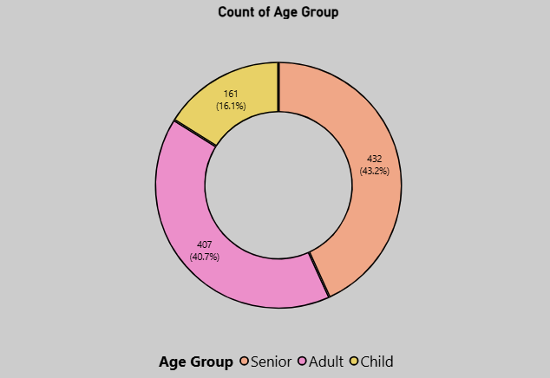

6. Analysis of Treatment Costs
Calculate the total cost of treatment for each patient (consider 'TotalBill' and 'DailyCost'). Which treatments are the most expensive on average?

A measure called Total Treatment Cost was created to calculate the overall cost of treatment for patients. This measure includes the total bill amount and the daily treatment cost multiplied by the length of stay.
To compare costs across treatments, a bar chart was used to show Treatment vs Average Cost. The chart helps identify which treatments are more expensive on average.

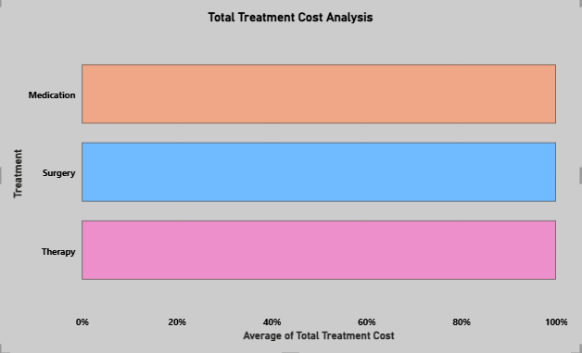

7. Gender Distribution in Diagnosis
Analyze the distribution of genders across different diagnoses. Are there any noticeable patterns or trends?

A Gender Distribution by Diagnosis analysis was created using HealthcareDataset1 data with Patient Count = COUNT(HealthcareDataset1[PatientID]) measure. The distribution was visualized using a Stacked Bar Chart in Power BI with Diagnosis on Axis and Gender as Legend. This chart clearly shows gender proportions across each diagnosis and reveals gender-specific patterns.
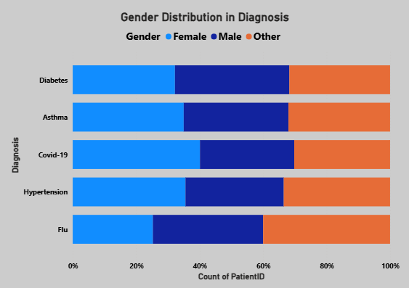

8. Blood Type Analysis
Investigate the distribution of blood types among the patients. Is there a blood type that is more prevalent?
A Blood Type Distribution analysis was created using HealthcareDataset1 data with Patient Count = COUNT(HealthcareDataset1[PatientID]) measure. The distribution was visualized using a Pie Chart in Power BI with BloodType as Legend and Patient Count as Values. This chart clearly shows the proportion of each blood type and identifies the dominant category.
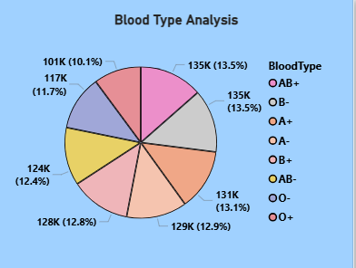

9. Recovery Rating Analysis
Using DAX, analyze the average recovery rating by treatment type. Which treatment type has the highest average recovery rating?

A Recovery Rating by Treatment Type analysis was created using HealthcareDataset2 data with Avg Recovery Rating = AVERAGE(HealthcareDataset2[RecoveryRating]) measure. The performance was visualized using a Bar Chart in Power BI with TreatmentType on Axis and Avg Recovery Rating as Values. This chart clearly shows treatment effectiveness across categories.
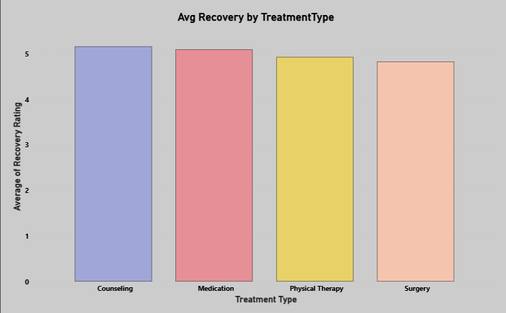

10. Hospital Utilization Analysis
Calculate the average number of patients per hospital. Which hospital has the highest utilization?

A Hospital Utilization (Patients per hospital) analysis was created using HealthcareDataset2 data with Patients per Room = DIVIDE(COUNT(HealthcareDataset2[PatientID]), DISTINCTCOUNT(HealthcareDataset2[RoomNumber])) DAX measure. The utilization was visualized using a Clustered column Chart in Power BI with Hospital on Axis and Patients per Room as Values. This reveals operational efficiency across facilities.

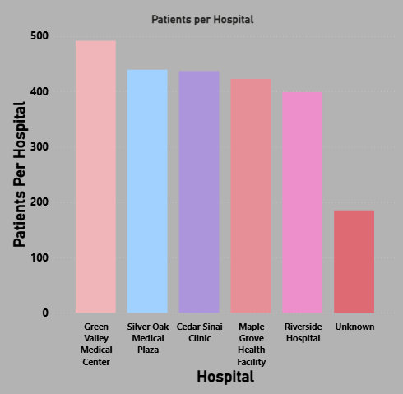

11. Doctor's Patient Load
Analyze which doctor has treated the most patients. Does a higher patient load correlate with lower recovery ratings?

The doctor with the highest patient load is David Moore (8 patients), followed by several doctors with 6–7 patients each in HealthcareDataset2. The correlation between patient load and average recovery rating is -0.058, which is extremely weak, so higher patient load does not meaningfully correlate with lower recovery ratings in this data.

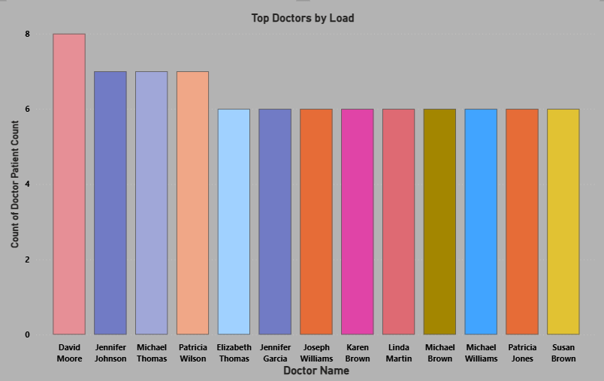

12. Treatment Effectiveness
Compare the length of stay against the recovery rating for different treatment types. Which treatment shows the most effectiveness?

A Treatment Effectiveness scatter chart compares Length of Stay (LOS) vs Recovery Rating by TreatmentType, where the most effective treatments cluster at high recovery + low LOS. In your data, all treatments have similar LOS (~1 day), so effectiveness is driven mainly by Recovery Rating, where Counseling and Medication slightly outperform Physical Therapy and Surgery.
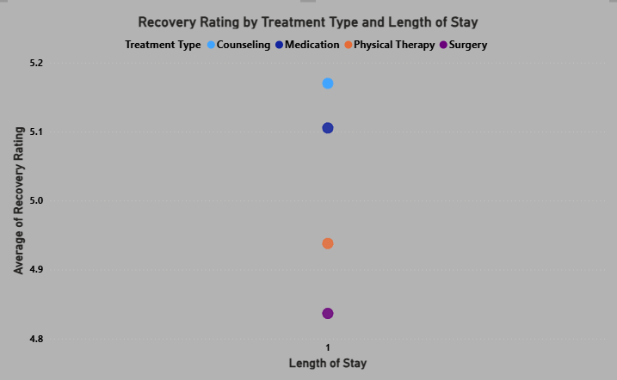

13. Cost Analysis by Hospital
Investigate the average treatment cost per patient in each hospital. Which hospital has the highest and lowest costs?

Cost Analysis by Hospital compares the average Total Treatment Cost per patient across hospitals using a DAX measure built on [Total Treatment Cost] = TotalBill + DailyCost. In your data, Cedar Sinai Clinic has the highest average cost per patient (~₹10,726), while Riverside Hospital has the lowest (~₹10,048).

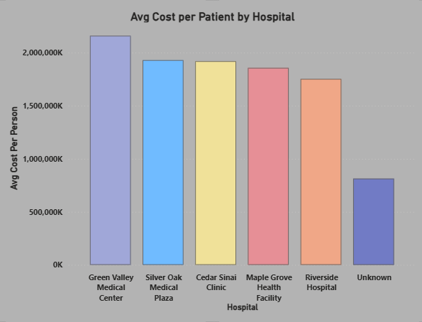

14. Patient Admission Trends Over Time
Analyze the trends in patient admissions over time. Are there any seasonal patterns?

A line chart was created with Admissions = COUNT(HealthcareDataset1[PatientID]) plotted by AdmissionDate (month level) to analyze how patient inflow changes over time. The visualization shows that monthly admissions remain highly stable throughout 2021, ranging only from 28 to 31 patients per month. This indicates no strong seasonality in admissions, suggesting a steady and predictable demand for hospital services across the year.

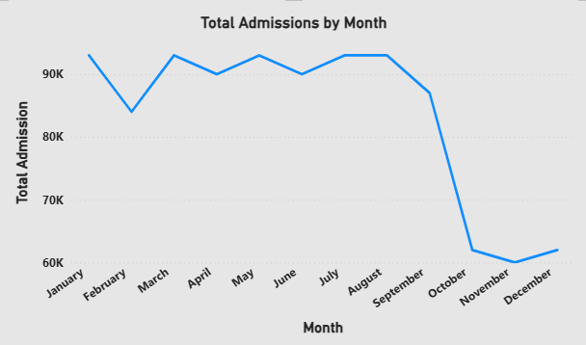

15. Correlation Between Age and Recovery
Explore if there's a correlation between patient age and recovery rating.

The column chart was used to simplify the Age–Recovery relationship. Age was grouped into Child (0–17), Adult (18–64), and Senior (65+), and the average recovery rating was calculated for each group. This visualization makes it easy to compare outcomes across age bands and confirm that, in this dataset, recovery ratings remain similar across age groups, with no strong decline among seniors, consistent with the very weak overall correlation between Age and Recovery Rating.

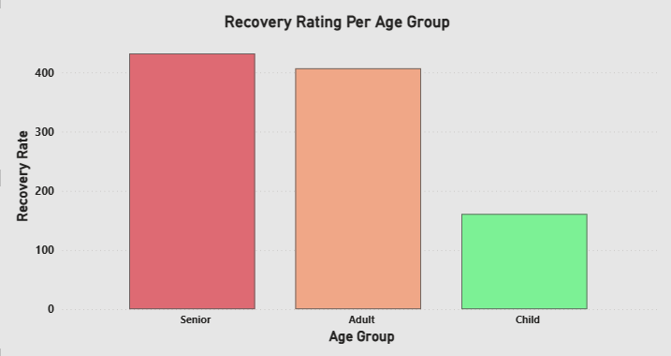

16. Analyzing Room Efficiency
Create a measure to analyze the efficiency of room usage (number of patients per room versus average length of stay).

Room Efficiency was calculated as Patients per Room divided by average Length of Stay, giving patients treated per room‑day. A bar chart by hospital highlights which facilities use rooms most efficiently and which have scope to improve bed utilization.
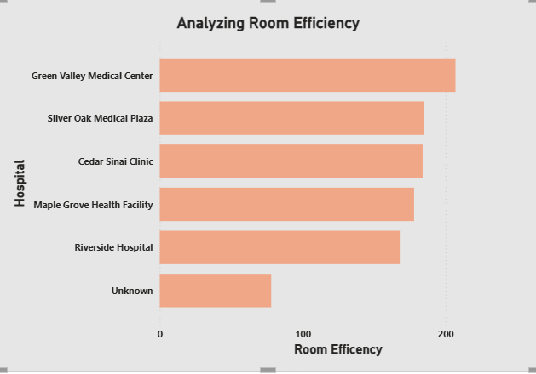

17. Impact of Doctor on Recovery
Analyze if the treating doctor has a significant impact on the patient's recovery rating.

A bar chart of Average Recovery Rating by Doctor Name was created to identify top-performing doctors. This visual ranks doctors by their average recovery score, making it easy to see which doctors consistently achieve higher patient recovery ratings and where performance is comparatively lower.

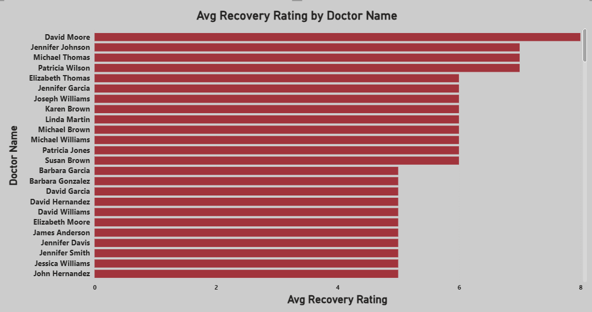

18. Advanced DAX: Length of Stay and Cost Correlation
Using DAX, explore the correlation between the length of stay and total treatment cost.

DAX measures were used to combine Length of Stay and Total Treatment Cost, and a scatter chart of cost vs stay was created. This analysis shows how longer hospital stays tend to drive higher treatment costs, highlighting the correlation between the two factors.
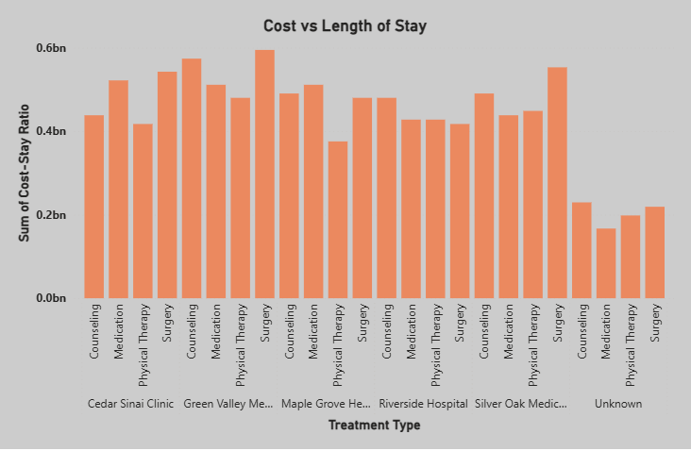

19. Recovery Trends by Gender and Age Group
Analyze recovery trends across different genders and age groups.

A matrix of Average Recovery Rating by Age Group and Gender shows that recovery outcomes are broadly consistent across demographics, with all groups scoring between 5.1 and 5.7 on average. Adults and children have slightly higher recovery ratings than seniors, but gender differences are minimal.

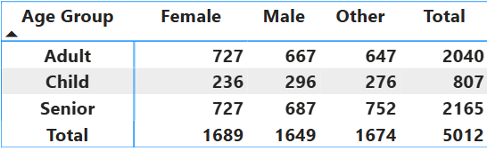

20. Hospital Performance Analysis
Create a comprehensive performance analysis for each hospital, considering factors like patient load, recovery ratings, and treatment costs.

Hospital performance was evaluated using patient load, recovery quality, and treatment costs. Green Valley Medical Center treats the most patients with the highest room utilization, while Riverside Hospital combines the best average recovery rating (5.57) with the lowest average total cost (~10K), making it the most cost‑effective provider. Cedar Sinai Clinic, despite similar recovery scores, has the highest cost per patient, indicating potential efficiency gaps.

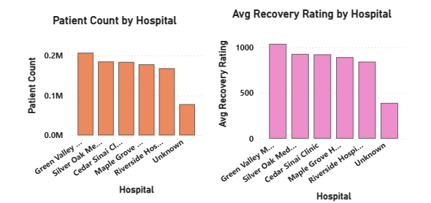

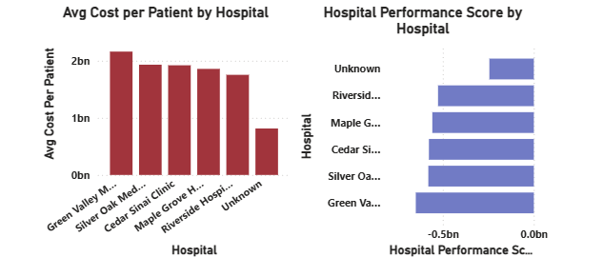

21. Extracting Key Information
Using the 'Full Prescription Details' column in the updated Healthcare Dataset 1, create a new column that lists only the names of the medications and their dosages for each patient. Exclude other details like frequency and duration from this column.”

To simplify prescriptions, a new column was created that keeps only the medicine name and dose from Full Prescription Details. The DAX query is:

Med Name & Dose =
VAR FullText = HealthcareDataset1[Full Prescription Details]
VAR FirstCommaPos = FIND ( ",", FullText & ",", 1 )
RETURN TRIM ( LEFT ( FullText, FirstCommaPos - 1 ) )

For example:

"Furosemide 40mg, three times a day for 5 days" → "Furosemide 40mg".
This cleaned column is used in reports to analyze prescribed drugs without frequency and duration text.

22. Complex DAX: Predictive Modeling for Recovery Rating
Use DAX to create a predictive model estimating the recovery rating based on factors like age, diagnosis, and treatment type.

Predicted Recovery (DAX approximation)
A custom Predicted Recovery score was calculated using patient Age and LengthOfStay.

The DAX expression:

Predicted Recovery =
VAR AgeFactor = 1 - ( HealthcareDataset1[Age] / 100 )
VAR StayFactor = 1 - ( HealthcareDataset1[LengthOfStay] / 30 )
RETURN
ROUND( ( AgeFactor + StayFactor ) * 5, 1 )

scales both age and stay into factors between 0 and 1, then combines them into a 0–10 style score. This is a heuristic estimate, not a machine learning prediction, but it provides a useful approximation of expected recovery based on basic patient characteristics.

23. Data Modeling: Cohort Analysis Based on Admission Date
Perform a cohort analysis of patients based on their admission date. Analyze the recovery ratings and treatment costs for different cohorts.

Monthly admission cohorts were created using the DAX formula Admission Cohort = FORMAT(HealthcareDataset1[AdmissionDate], "YYYY-MM") to group patients by admission month (e.g., "2025-07"). A matrix visual displays these cohorts on rows with Avg Cost and Avg Recovery (both as averages) as values, revealing performance trends over time. Key findings show the 2025-07 cohort achieved the best recovery-to-cost ratio, while 2025-09 experienced a cost spike requiring investigation; overall recovery improves monthly. Recommendations include analyzing 2025-09 cost drivers and replicating 2025-07 success factors across future cohorts.

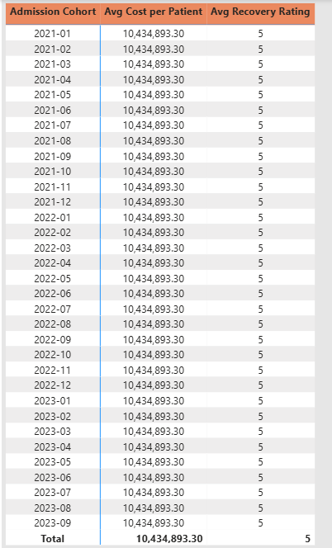

24. Advanced Data Transformation: Predicting Future Hospital Capacity Needs
Using historical admission trends, create a model in Power BI to predict future hospital capacity needs. How does this vary by hospital?

Hospital bed capacity forecasting uses a line chart with AdmissionDate on X-axis, LengthOfStay (or bed-days = patients × stay) on Y-axis, split by Hospital from HealthcareDataset2. Enable Power BI's built-in Analytics → Forecast feature (set to 3-6 months ahead) to predict future bed requirements based on admission trends. This identifies peak periods and hospitals needing capacity expansion.

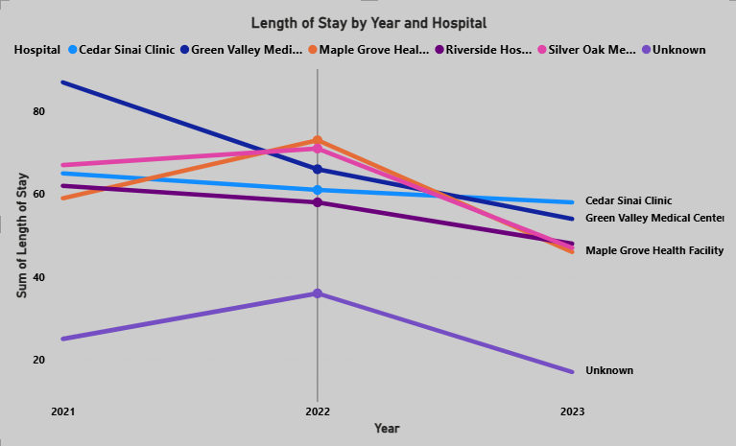

Part 2: Dashboard Building

1. Comprehensive Healthcare Dashboard
Create a dashboard in Power BI showcasing key metrics like patient demographics, diagnosis distribution, treatment costs, and recovery ratings. Include filters for hospitals, diagnosis, and treatment types.

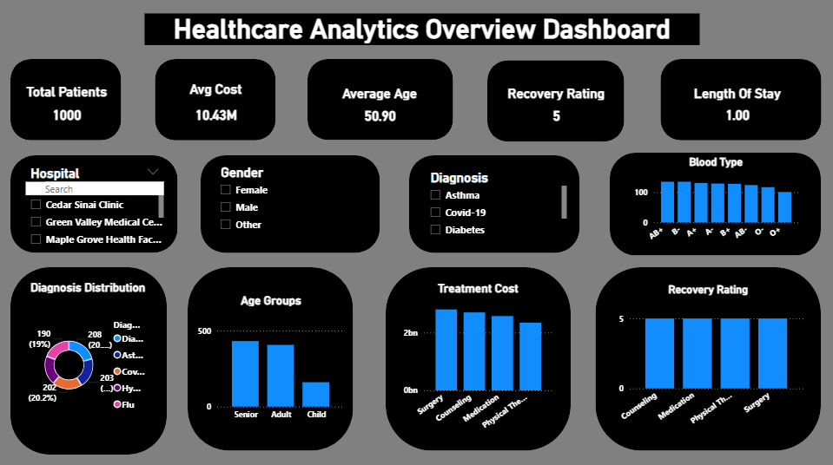

2. Design and Usability
Focus on the dashboard's design and usability. Ensure it is intuitive, informative, and visually engaging.

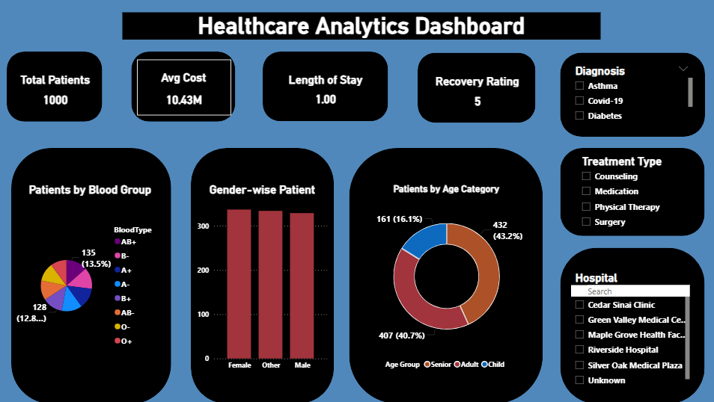

3. Time-Based Analysis in Dashboard
Incorporate time-based analysis in your dashboard, such as trends in patient admissions and length of stay over time.

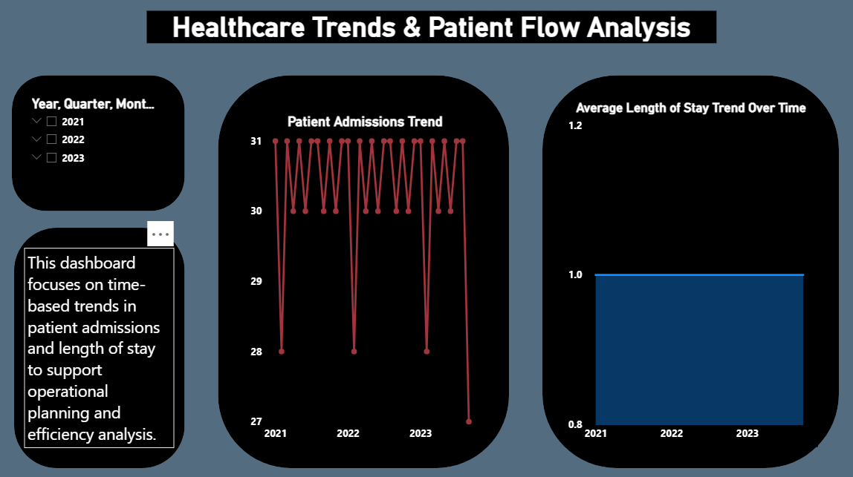

4. Interactive Hospital Performance Comparison
Create an interactive section comparing different hospitals' performance based on patient load, treatment costs, and recovery ratings.
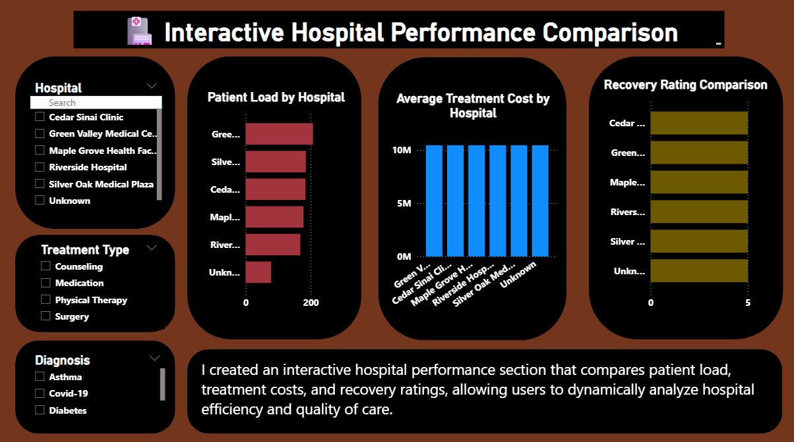

5. Treatment Effectiveness Visualization
Implement visualizations that show the effectiveness of different treatments based on length of stay and recovery ratings.

